GREEDY ALGORITHM

**NAME:ENIYA.B.A**

**ROLL NO: 230701085**

## 1-G-Coin Problem

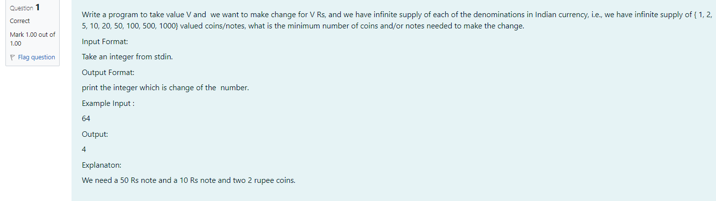

**CODE:**

#include<stdio.h>

int main(){

int v,c=0;

scanf("%d",&v);

int a[]={1000,500,100,50,20,10,5,2,1};

for(int i=0;i<9;i++){

c+=v/a[i];

v%=a[i];

}

printf("%d",c);

}

**OUTPUT:**

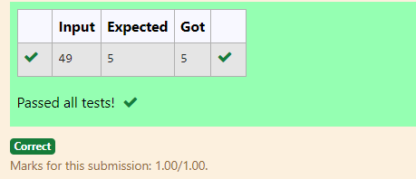

2-G-Cookies Problem

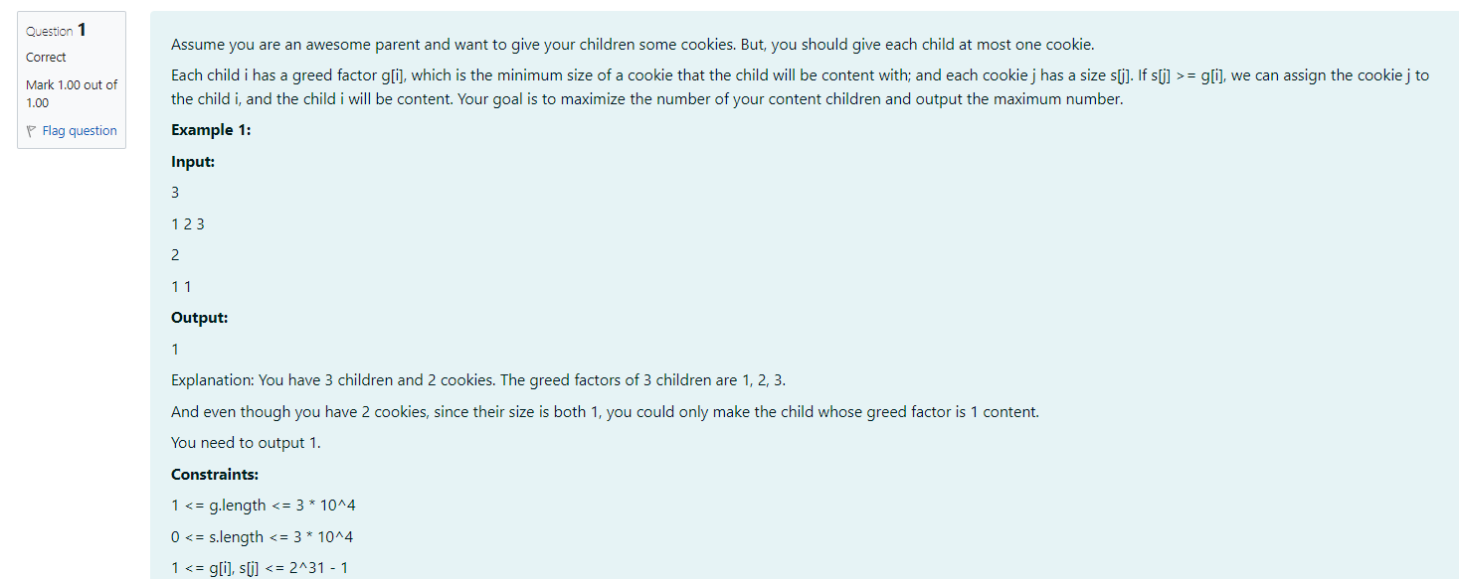

**CODE:**

#include<stdio.h>

int main()

{

int c,ck,count=0;

scanf("%d",&c);

scanf("%d",&ck);

int g[c],s[ck];

for(int i=0;i<c;i++){

scanf("%d",&g[i]);}

for(int j=0;j<ck;j++){

scanf("%d",&s[j]);}

for(int i=0;i<c;i++){

for(int j=0;j<ck;j++){

if(g[i]>=s[j]){

count+=1;

break;

}

}

}

printf("%d",count);

}

**OUTPUT:**



3-G-Burger Problem

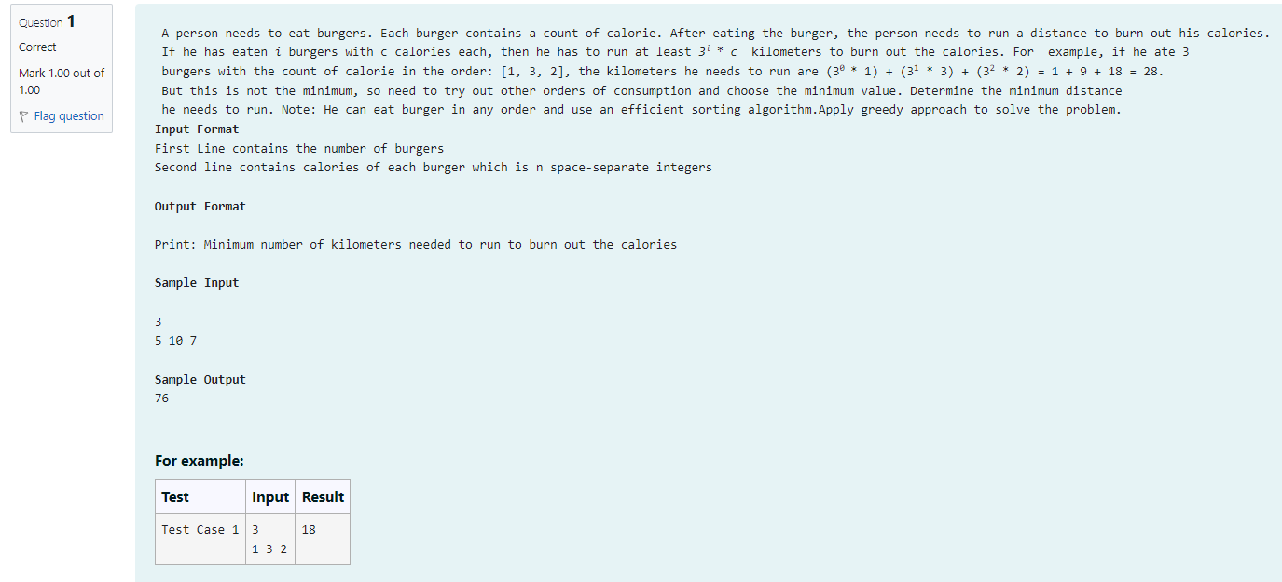

**CODE:**

#include<stdio.h>

#include <math.h>

void bubbleSort(int arr[], int n);

int main(){

int bgrs;

scanf("%d",&bgrs);

int cal[bgrs];

for(int i=0;i<bgrs;i++){

scanf("%d",&cal[i]);

}

bubbleSort(cal,bgrs);

int km=0;

int i=0;

int c=bgrs-1;

while(c>=0){

km+=pow(bgrs,i)*cal[c];

i++;

c--;

}

printf("%d",km);

}

void bubbleSort(int arr[], int n) {

int i, j, temp;

int swapped;

for (i = 0; i < n-1; i++) {

swapped = 0;

for (j = 0; j < n-i-1; j++) {

if (arr[j] > arr[j+1]) {

temp = arr[j];

arr[j] = arr[j+1];

arr[j+1] = temp;

swapped = 1;

}

}

if (swapped == 0) {

break;

}

}

}

**OUTPUT:**

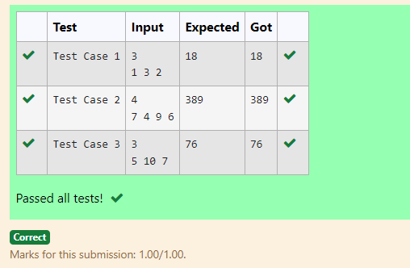

4-G-Array Sum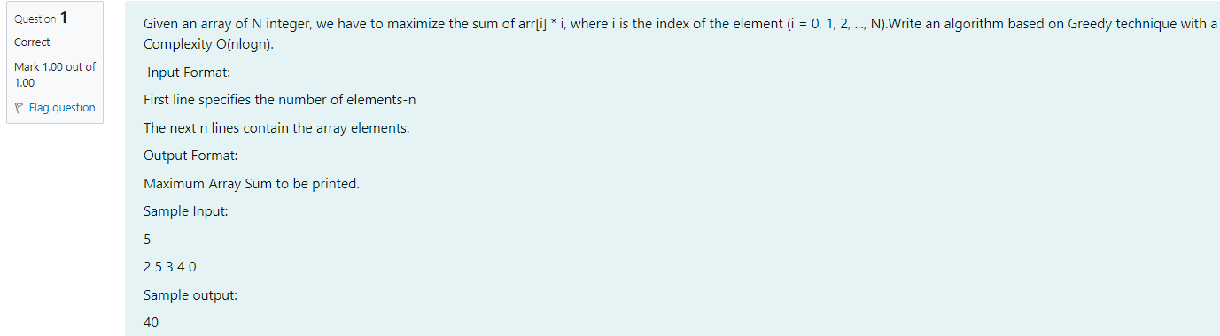

**CODE:**

#include<stdio.h>

int main()

{

int n;

scanf("%d",&n);

int a[n];

for(int i=0;i<n;i++)

{

scanf("%d",&a[i]);

}

int temp = 0;

for (int i = 0; i < n; i++)

{

for (int j = i+1; j < n; j++)

{

if(a[i] > a[j]) {

temp = a[i];

a[i] = a[j];

a[j] = temp;

}

}

}

int sum=0;

for(int i=0;i<n;i++)

{

sum+=(a[i]*i);

}

printf("%d",sum);

}

**OUTPUT:**

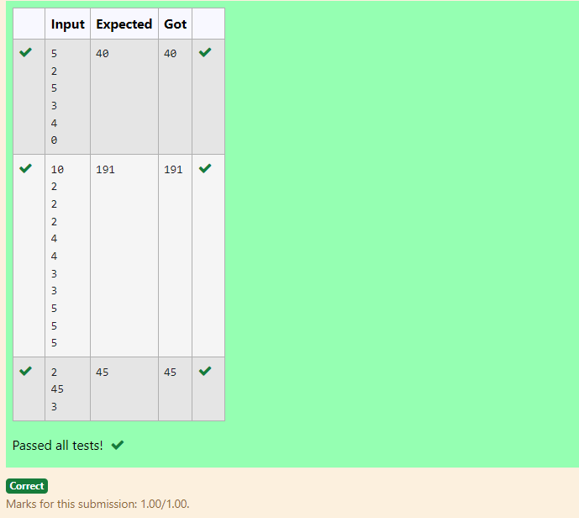

## 5-G-Product of Array elements-Minimum

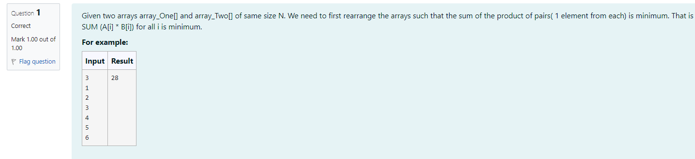

**CODE:**

#include<stdio.h>

int main()

{

int n;

scanf("%d",&n);

int a[n],b[n];

for(int i=0;i<n;i++)

{

scanf("%d",&a[i]);

}

for(int i=0;i<n;i++)

{

scanf("%d",&b[i]);

}

int temp = 0;

for (int i=0;i<n;i++)

{

for(int j=i+1;j<n;j++)

{

if(a[i]>a[j])

{

temp=a[i];

a[i]=a[j];

a[j]=temp;

}

}

}

for (int i= 0; i < n; i++)

{

for (int j=i+1;j<n;j++)

{

if(b[i]<b[j])

{

temp=b[i];

b[i]=b[j];

b[j]=temp;

}

}

}

int min=0;

for(int i=0;i<n;i++)

{

min+=(a[i]*b[i]);

}

printf("%d",min);

}

**OUTPUT:**

